SERIES TEST- APRIL 2017

Qn 1: What are the features of BASH shell?
Features of BASH shell
- Redirection
Command < file
If we use standard input streams
Command 0< file
Command 1> file, command >> file (to append)
Command >|file (used to forcefully write)
Command 2>&1 (command substitution)
- Command substitution
Convert the output to string. It uses parenthesis.
Eg. (date)
- Reading writing input and output
Eg.read a
echo $a
- Initialise variables
Syntax: variable = value
Eg. a= $1
- Exit status we use $?
- Alias
Customised commands (gives names for commands)
Syntax: alias definition command
Eg.alias x ls
Unalias command
Qn 2: Write a script that will add 2 numbers, which are supplied as command line arguments.
#!/bin/ksh
a=$1
b=$2
((c=$a+$b))
Print $a”+”$b”=”$c
Qn 3: With examples show some usage of grep commands?
global regular expression print(GREP)
- used to search the input file for all lines that match a specified regular expression and write them to the standard output
grep operation
- for each line in the standard input file, grep performs the following operations
- copies next input to the pattern space. pattern space is a buffer that can hold one line of text
- applies the regular expression on that line
- if there is a match, the line is copied from the pattern space to the output
- grep utilities perform these three operations on each line in the input
grep is a search utility.
It can search only for the existence of a line that matches a regular expression
If a line matches with regular expression, it is send to the output
If the line does not match the RE , it is not printed
The line selection is based on the RE
grep is a filter
grep cannot be used to add, delete or change a line
grep cannot be used to print only a part of a line
grep cannot read only a part of a file
grep cannot select a line based on the contents of previous or next line
Qn 4. Bring out the user defined functions in awk.
Functions are basic building blocks of a program. AWK allows us to define our own functions. A large program can be divided into functions and each function can be written/tested independently. It provides re-usability of code.
Given below is the general format of a user-defined function:

functionfunction_name(argument1,argument2,…)
{
function body
}
In this syntax, the function_name is the name of the user-defined function. Function name should begin with a letter and the rest of the characters can be any combination of numbers, alphabetic characters, or underscore. AWK's reserve words cannot be used as function names.
Functions can accept multiple arguments separated by comma. Arguments are not mandatory. You can also create a user-defined function without any argument.Function body consists of one or more AWK statements.

Example
# Returns minimum number
functionfind_min(num1, num2){
if(num1 < num2)
return num1
return num2
}
# Returns maximum number
functionfind_max(num1, num2){
if(num1 > num2)
return num1
return num2
}
# Main function
function main(num1, num2){
# Find minimum number
result=find_min(10,20)
print"Minimum =", result

# Find maximum number
result=find_max(10,20)
print"Maximum =", result
}
# Script execution starts here
BEGIN{
main(10,20)
}

Output
Minimum = 10
Maximum = 20

Qn 5: Explain eval command with example
eval Command
- The eval command is used when the Korn shell needs to evaluate a command twice before executing it.
- To generalize a segment of code, we need to store the name of a variable in a second variable and then use the print command to display the value of the original variable.
- $ x=23
- $ y=x
- $ print $y
- X
- The solution is to use the eval command so that the shell evaluates the command twice.
- $ x=23
- $ y=x
- $ eval print \$$y
- 23
- When the eval command is executed, it first evaluates $y, which generates the string value $x.
- The second evaluation then evaluates the variable $x, which produces the correct effect, the printing of the variable stored in y.
Qn 6. With examples explain different string functions in awk.
- index
Returns the first position of a substring within a string.
Syntax:
index(string,substring)
Example:
{
loc=index(MISSISSIPI, ”IS” )
print loc
}
output: 2
- length
Length returns the number of characters in the string.
Syntax:
length(string)
Example:
{
len=length($0)
print len
}
- substring
Extracts a substring from a string
Syntax:
substr (string , position)
substr (string , position, length)
Example:
{
sub =substr (missisipi , 3)
sub =substr (missisipi , 3, 3)
}
- split
split(string, array)
split(string, array, fieldseparator)
  - divides string into pieces separated by fieldseparator, and stores the pieces in array
  - if the fieldseparator is omitted, the value of FS is used.
Example:
split("auto-da-fe", a, "-")
sets the contents of the array a as follows:
a[1] = "auto"
a[2] = "da"
a[3] = "fe"
- substitution
Substitute one string value for another
Syntax:
sub (reg _exp, replacementstring , inputstring)
Example:
success=sub (/bird/, ”animal”, $0)
sub returns 1 , if substitution was successful otherwise 0
- global substitution
Substitute all occurrences of a value
Syntax:
gsub (reg _exp, replacementstring , inputstring)
Example:
gsub (/bird/, ”animal”, $0)
- match
Returns the starting position of the matching expression
Syntax:
startpos=match (string, regexp)
Example:
startpos=match ($0, regexp)
- tolower(string)
returns a copy of string, with each upper-case character converted to lower-case. Nonalphabetic characters are left unchanged.
Example:tolower("MiXeDcAsE 123")
returns "mixed case 123"
- toupper(string)
returnsa copy of string, with each lower-case character converted to upper-case.
Qn 7. With suitable examples explain sed commands?
- sed scans the input file, line by line, and applies a list of instructions(sed script) to each line in the input file.
- the script ,which is usually a separate file, can be included in the sed command line if it is a one line command
- it does not change anything in the original file
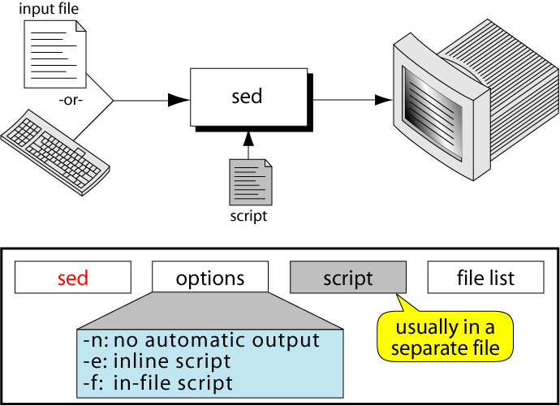

sed script format
- instructions included in command line
sed -e ‘address command’ input _file
- instructions placed in a file
sed –f script.sed input _file
create script file using text editor
save file with .sed extension
address command
- each instruction consists of address and command
- address select the line to be processed by the command
- ! is optional .select the non matching line
- command indicates the action that sed is to apply to each input line that matches the address
sed operation
- each line in the input file is given a line number by sed
- this number is matched against the address
- copies an input line to the pattern space
- applies all the instructions in the script, one by one, to all pattern space lines that match the specified address in the instruction
- copies the content of the pattern space to the output file unless directed not to by the -n option flag
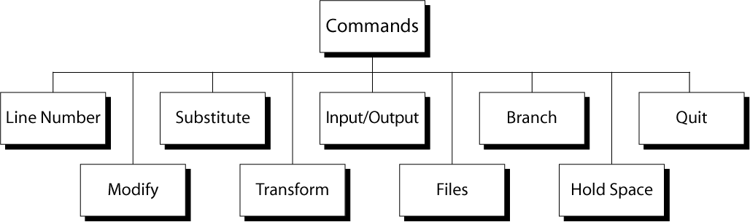

Line number command (=)
- put line number at the beginning of the line
- line number is written on a separate line
Eg
sed “=” file1
sed “/^o/=“ file1
modify commands
- commands are used to insert, append, change ,or delete one or more whole lines
- The modify command require that any text associated with modify command be placed on the next line in the script
- therefore the script must be in a file
- all modify command apply to the whole line
- cannot modify just a part of a line
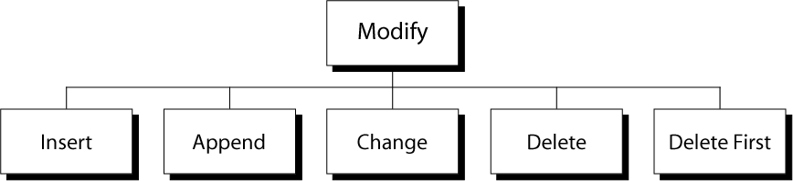

substitute command (s)
- replaces text that is selected by regular expression with a replacement string
- similar to find and replace
- address s/ pattern/replacement string/flag(s)
- replaces text that is selected by regular expression with a replacement string
- similar to find and replace
- address s/ pattern/replacement string/flag(s)
transform command
- transform one set of characters to another set
- each character in the first string represents a value to be changed to its corresponding characters in the second string
- sed ‘y/aeiou/AEIOU’ input_file
I/O Commands
- sed automatically reads text from the input file and writes data to standard output
- I/O commands allows the user to control the input and output
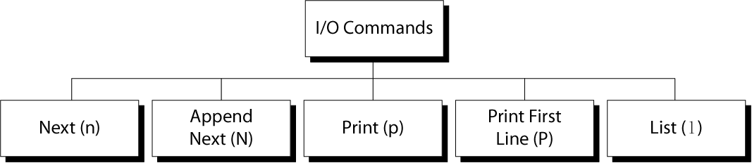

File Commands
- allows to read and write from/to file while processing standard input
- read:
- address r filename
- write:
- address w filename
Branch Commands
- Change the regular flow of the commands in the script file
- allow to skip one or more commands in the script file
- Branch label
  - Each branch command must have a target, either a label or the last instruction in the script
  - If “label” is supplied, execution resumes at the line following :label; otherwise, control passes to the end of the script
Quit (q) Command
Syntax: [addr]q
  - Quit (exit sed) when addr is encountered.
Example: Display the first 50 lines and quit
% sed -e ’50q’ datafile

Qn 8. Explain the use of awk command and its associative arrays with suitable examples.
Use
awk command searches files for text containing a pattern. When a line or text matches, awk performs a specific action on that line/text. The Program statement tells awk what operation to do; Program statement consists of a series of "rules" where each rule specifies one pattern to search for, and one action to perform when a particular pattern is found. A regular expression enclosed in slashes (/) is an awk pattern to match every input record whose text belongs to that set.
Examples
To print the length of the longest input line.
$ awk '{ if (length($0) > max) max = length($0) } END { print max }' sample.txt
13
To print seven random numbers from zero to 100, inclusive.
$ awk 'BEGIN { for (i = 1; i<= 7; i++) print int(101 * rand()) }'
24
29
85
15
59
19
81

Associative arrays
- Arrays with the index values as string are called associative arrays.
- Index must be unique: each index must be associated with an array value only once.
- Data values may be duplicated.
- The association of the index with its value is guaranteed.
- There is no ordering imposed on the indexes.
- An array index cannot be sorted. The data values in the array can be sorted.

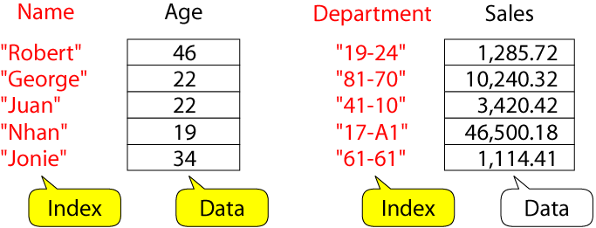

Example: process sales data
- input file:
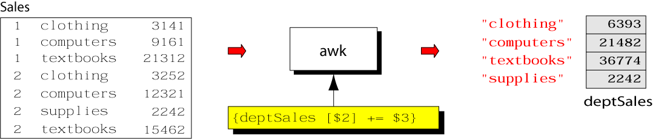

- output:
  - summary of category sales
- awk program:
% cat sales.awk
{
deptSales[$2] += $3
}
END {
for (x in deptSales)
print x, deptSales[x]
}
% awk –f sales.awk sales
Qn 9. Write a shell script to print a number in reverse order

#!/bin/bash
echo“Enter a number”
readnum
rev=0
while [ $num –gt 0 ]
do
num=`expr $num% 10`
rev=`expr $rev * 10`
rev=`expr $rev + $rem`
num=`expr $num/ 10`
done
echo “Reverse is”
echo $rev

Save program as rev.sh
Compile it as $sh rev.sh
Qn 10. Write a shell script to find the sum of digits of a number
#!/bin/bash
echo “Enter a number”
readnum
sum=0
while [ $num –gt 0 ]
do
rem=`expr $num % 10`
sum=`expr $sum + $rem`
num=`expr $num / 10`
done
echo “The sum of digits is”
echo $sum

Save the program as sum.sh
Compile it as $sh sum.sh
Qn 11. Explain command history and command execution process?
History command
- The command for listing, editing and executing commands from the history file
- Executed without any options , the history commands lists the last 16 commands.
- history
- We can control the number of commands listed by providing a number as a history command argument
- history 10
Command Execution Process
- To understand the behaviour of the shell, it helps to understand how C executes a command. Command execution is carried out in six sequential steps
- Command parsing
- Variable evaluation
- Command substitution
- Redirection
- Wildcard expansion
- Path determination
- Command Parsing
The shell first parses the command into words. In this step, it uses whitespaces as delimiters between the words. It also replaces sequences of two or more spaces or tabs with a single space.
- Variable Evaluation
After completely parsing the command, the shell looks for variable names (unquoted words beginning with a dollar sign). When a variable name is found, its value replaces the variable name
- Command Substitution
The shell then looks for a command substitution. If found, the command is executed and its output string replaces the command
- Redirection
At this point, the shell checks the command for redirected files. Each redirected file is verified by opening it.
- Wildcard Expansion
When filenames contain wildcards, the shell expands and replaces them with their matching filenames. This step creates a file list.
- Path Determination
In this last step, the shell uses the PATH variable to locate the directory containing the command code. The command is now ready for execution.
Qn 12: Write a script using case statement to perform basic math operations as follows
+ addition
- subtraction
* multiplication
/ division
The name of script must be ‘calc’ which works as follows
$ sh calc.sh 20 + 3
Also check for sufficient command line arguments.
calc.sh
If [ $# != 3]
then
echo “ insufficient command line arguments “
else
a= $1
b= $2
c= $3
case $2 in
+) r=`expr $a+ $c`
echo “ $a+ $c= $r”
;;
-) r= `expr $a - $c`
echo “ $a- $c = $r”
;;
\*) r= `expr $a\* $c`
echo “ $a * $c = $r”
;;
/) r= `expr $a / $c `
echo “$a/ $c = $r”
;;
esac
fi

